14.1.9 Editors - Movie Clip Editor - Header - Mask Mode - Add Menu
Add Menu 1
Circle 1
Last Operator Add Circle 1
Size 1
Location X Y 1
Square 2
Last Operator Add Square 2
Size 2
Location X Y 2
Adding more curve points 2
Last operator Add Vertex and Slide 2
Location X Y 2

Add Menu

Masking can be done by using curves. In the Add menu you will find two spline primitives. You can choose between a circle Bezier curve object and a square Bezier curve object.

You select curve points by clicking with the left mouse button at them. Holding down Shift will add to the selection. Clicking in the off will deselect everything.

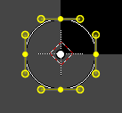
Circle
Adds a Bezier circle that you can use for masking.

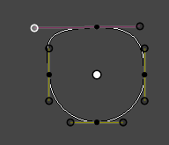
This circle element can be modified by right clicking at the handlers and pulling at the handlers until the desired result is achieved. The yellow points are handlers. The whole curve can be moved around with right mouse button. See also Transform sub menu in the Mask menu.

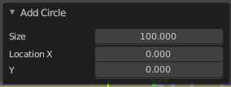
Last Operator Add Circle

Size
The size of the circle.

Location X Y
The location of the circle.

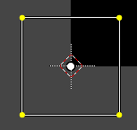
Square
Adds a Bezier circle that you can use for masking.

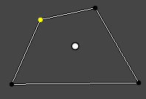
This circle element can be modified by right clicking at the handlers and pulling at the handlers until the desired result is achieved. The yellow points are handlers. The whole curve can be moved around with right mouse button. See also Transform sub menu in the Mask menu.

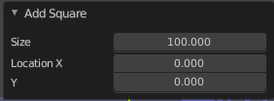
Last Operator Add Square

Size
The size of the circle.

Location X Y
The location of the circle.

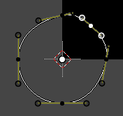
Adding more curve points
You can add more curve points by holding down ctrl and clicking left at a curve.
You can create a spline from scratch with this method too. Simply hold down Ctrl, click into the viewport, and created your needed spline points. To close the created mask spline use Toggle Cyclic from the mask menu.

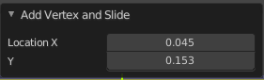
Last operator Add Vertex and Slide

Location X Y
The location of the created spline point.

